

KING KHALID UNIVERSITY COLLEGE OF COMPUTER SCIENCE

INVENTORY MANAGEMENT SYSTEM
By

Name | Academic Number | Role
Renad Mohammed Alshahri | 444xxxxxx | Project Manager
Wajd Yahya Asiri | 444xxxxxx | Risk Manager & Documentation Specialist

Course Code: 444CCS-3

Course Name: Software Project Management Instructor: Dr.
2nd Semester – AY 1447

Abstract
This report presents the project management plan for the development of an Inventory Management System (IMS). The system is designed to automate and streamline inventory tracking, stock control, and reporting processes for a retail or warehousing environment. This document covers all phases of the project lifecycle, from planning and organization through risk management and conclusion. It applies standard software project management methodologies including scope definition, work breakdown structure, Gantt scheduling, cost estimation, risk identification, and communication planning. The project is carried out by a team of two students as part of the 444CCS-3 Software Project Management course at King Khalid University.

Table of Contents
Chapter 1: Project Introduction 6
1.1 Project Overview 6
1.2 Project Scope 6
1.3 Team Structure 7
1.4 Key Stakeholders 7
Chapter 2: Project Planning and Organization 8
2.1 Software Project Lifecycle Model 8
2.2 Work Breakdown Structure (WBS) 9
2.3 Project Schedule 10
2.4 Resource Allocation 11
Chapter 3: Project Management Plan 12
3.1 Scope Management 12
3.2 Time Management 12
3.3 Cost Management 12
3.4 Communication Management 13
Chapter 4: Risk Management 14
4.1 Risk Identification & Analysis 14
4.2 Risk Response Planning 14
4.3 Monitoring and Reporting 15
Chapter 5: Conclusion 16
References 17

List of Figures
Figure 1: Agile Scrum Lifecycle Model 7
Figure 2:Work Breakdown Structure (WBS) 8
Figure 3:Gantt Chart Schedule 9

List of Tables
Table 1: Team Structure 6
Table 2:Key Stakeholders 6
Table 3:Project Schedule 7
Table 4:Resource Allocation 8
Table 5:Cost Management 9
Table 6:Risk Identification & Analysis 11
Table 7:Risk Response Planning 11

Chapter 1: Project Introduction

Project Overview
The Inventory Management System (IMS) is a software solution designed to help businesses efficiently manage their inventory, track stock levels, process orders, and generate detailed reports. The system eliminates manual inventory tracking processes that are prone to errors and inefficiencies.
Objectives:
    - Automate the tracking of inventory items across multiple storage locations.
    - Provide real-time stock level visibility to authorized users.
    - Enable efficient order processing, restocking alerts, and supplier management.
    - Generate comprehensive inventory reports for decision-making.
    - Reduce inventory costs by minimizing overstocking and stockouts.
Justification: Manual inventory management leads to errors, delays, and financial losses. An automated IMS will improve accuracy, reduce operational costs, and enhance decision- making capabilities for the organization.

Project Scope
In Scope:
    - User authentication and role-based access control (Admin, Manager, Staff).
    - Product catalog management (add, edit, delete, categorize items).
    - Stock level tracking with automated low-stock alerts.
    - Purchase order management and supplier database.
    - Sales order processing and invoice generation.
    - Reporting module: stock reports, sales reports, audit trails.
    - Web-based interface accessible from desktop browsers. Out of Scope:
    - Mobile application development.
    - Integration with third-party ERP systems.
    - Hardware barcode scanner integration. Success Criteria:
    - System deployed and functional within the 12-week timeline.
    - All core modules tested and passing acceptance criteria.
    - User manual and technical documentation delivered.
    - Project delivered within the estimated budget.

Team Structure

Table 1: Team Structure
Role | Responsibilities | Student
Project Manager | Overall planning, coordination, scheduling, tracking progress, leading team meetings, scope and time management. | Renad Mohammed Alshahri
Risk Manager & Documentation Specialist | Risk identification, risk log maintenance, mitigation strategies, report writing, stakeholder communication, deliverable compilation. | Wajd Yahya Asiri

Key Stakeholders

Table 2:Key Stakeholders
Stakeholder | Type | Interest / Role
Project Team | Internal | Development and management of the project.
Course Instructor | Internal | Academic supervisor and evaluator.
End Users (Staff/Managers) | External | Will use the system daily for inventory operations.
Business Owner / Client | External | Requires the system for business operations.
Suppliers | External | Indirectly affected through purchase order processing.

Chapter 2: Project Planning and Organization

Software Project Lifecycle Model
The project will adopt an Agile (Scrum) lifecycle model with elements of traditional planning. Agile is chosen because the requirements may evolve during development, and iterative delivery allows for early feedback and course correction.
Justification for Agile:
    - Flexibility to accommodate changing requirements.
    - Iterative sprints (2-week cycles) ensure frequent deliverables.
    - Regular stakeholder feedback improves product quality.
    - Clear roles align well with our two-member team structure.
Sprint Plan: The project is divided into 6 sprints of approximately 2 weeks each, covering requirements analysis, design, development of each module, testing, and deployment.
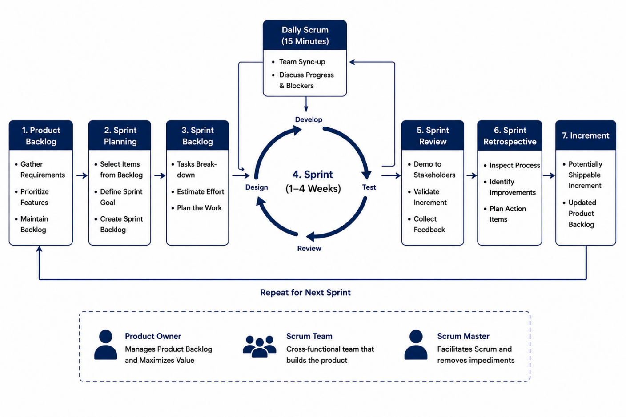

Figure 1: Agile Scrum Lifecycle Model

Work Breakdown Structure (WBS)
The WBS hierarchically decomposes the project into manageable tasks:
    - 1. Project Management: 1.1 Planning, 1.2 Monitoring, 1.3 Reporting
    - 2. Requirements: 2.1 Stakeholder Interviews, 2.2 Requirements Document, 2.3 Approval
    - 3. System Design: 3.1 Architecture Design, 3.2 Database Design, 3.3 UI/UX Wireframes
    - 4. Development: 4.1 Authentication Module, 4.2 Product Module, 4.3 Inventory Module, 4.4 Order Module, 4.5 Reporting Module
    - 5. Testing: 5.1 Unit Testing, 5.2 Integration Testing, 5.3 User Acceptance Testing
    - 6. Deployment: 6.1 Server Setup, 6.2 System Deployment, 6.3 User Training
    - 7. Documentation: 7.1 Technical Manual, 7.2 User Manual, 7.3 Final Report
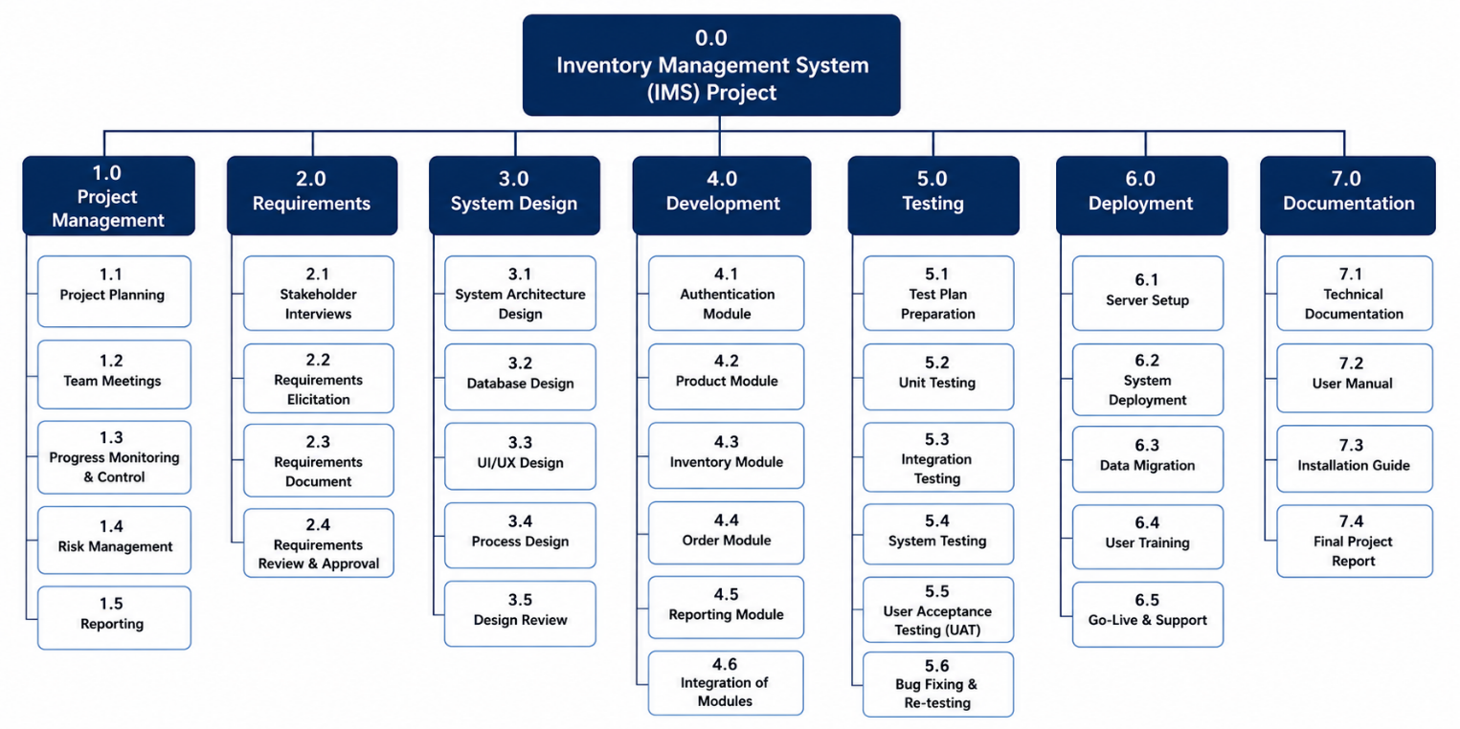

Figure 2:Work Breakdown Structure (WBS)

Project Schedule
The project spans 12 weeks. Key milestones:

Table 3:Project Schedule
Week | Phase / Task | Milestone | Responsible
1-2 | Requirements Gathering & Analysis | Requirements Document Approved | Renad Mohammed Alshahri
3-4 | System Design (Architecture, DB, UI) | Design Documents Complete | Both
5-6 | Development: Auth & Product Modules | Sprint 1 Review | Both
7-8 | Development: Inventory & Order Modules | Sprint 2 Review | Both
9 | Development: Reporting Module | Sprint 3 Review | Both
10 | Testing (Unit, Integration, UAT) | Testing Complete | Both
11 | Deployment & User Training | System Live | Renad Mohammed Alshahri
12 | Final Documentation & Report Submission | Project Closure | Wajd Yahya Asiri

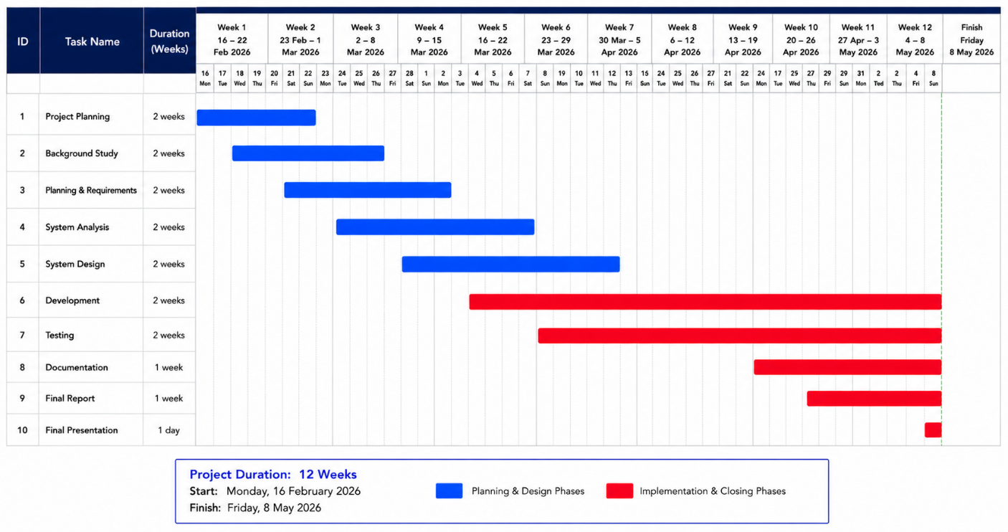
Figure 3: Gantt Chart Schedule

Resource Allocation

Table 4:Resource Allocation
Resource | Type | Role in Project | Availability
Renad Mohammed Alshahri | Human | Project Manager | Full project duration
Wajd Yahya Asiri | Human | Risk Manager & Doc Specialist | Full project duration
Visual Studio Code | Technical | Development IDE | Free – All sprints
GitHub | Technical | Version Control | Free – Full project
MySQL | Technical | Database Management | Free –  Development phase
GanttPro | Technical | Project Scheduling | Free trial
Microsoft Teams | Technical | Team Communication | University license
Blackboard | Technical | Submission Platform | University provided

Chapter 3: Project Management Plan

Scope Management
Scope management ensures the project includes all required work and only the required work. Requirements Definition Process:
    - Conduct stakeholder interviews to elicit requirements.
    - Document functional and non-functional requirements in a Software Requirements Specification (SRS).
    - Review and obtain formal approval from the instructor/client before development begins.
Scope Change Handling:
    - Any scope change request must be submitted in writing using a Change Request Form.
    - The project team evaluates impact on schedule, cost, and quality.
    - Changes approved by the Project Manager are incorporated into updated project documents.
    - A change log is maintained throughout the project.

Time Management
Time management ensures the project meets its 12-week deadline.
Detailed Schedule: Gantt chart maintained in GanttPro showing all tasks, durations, dependencies, and milestones (see Section 2.3).
Milestone Tracking:
    - Weekly progress reviews every Sunday to assess milestone completion.
    - Status reported in weekly meeting minutes.
    - Any delayed tasks flagged immediately for corrective action. Buffer Management:
    - Week 10 allocated for testing serves as a natural buffer.
    - Each sprint includes a 1-day buffer before the review meeting.
    - Critical path activities monitored closely to avoid deadline slippage.

Cost Management
Since this is an academic project, the cost is primarily measured in effort (hours). Estimated effort for two team members:

Table 5:Cost Management
Phase | Estimated Hours | Cost Equivalent (SAR 50/hr) | Notes
Requirements Analysis | 16 hrs | SAR 800 | Team effort
Design | 20 hrs | SAR 1,000 | Team effort

Development | 70 hrs | SAR 3,500 | Main development phase
Testing | 16 hrs | SAR 800 | Testing phase
Documentation | 14 hrs | SAR 700 | Reports and manuals
Deployment | 6 hrs | SAR 300 | Setup and training
Contingency Reserve | 14 hrs | SAR 700 | 10% buffer
Total | 156 hrs | SAR 7,800 | Full project
Tools used are either free (open-source) or available through university licensing, minimizing external costs.

Communication Management
Reporting Structure: Project Manager reports progress to the Instructor. Both team members report mutually and maintain shared documentation.
Meeting Calendar:
    - Weekly team meetings: Every Sunday at 7:00 PM via Microsoft Teams.
    - Sprint Review meetings: At the end of each 2-week sprint.
    - Ad-hoc meetings: As needed for critical issues. Documentation Tools:
    - Microsoft Word: For all formal reports and documentation.
    - GitHub Wiki: For technical documentation and code documentation.
    - Microsoft Teams: For daily communication and file sharing.
    - Blackboard: For formal submission of deliverables.
    - Meeting minutes documented and distributed within 24 hours of each meeting.

Chapter 4: Risk Management

Risk Identification & Analysis
The following risk log identifies potential risks with their probability (H/M/L) and impact (H/M/L) assessments:

Table 6:Risk Identification & Analysis
Risk ID | Risk Description | Probability | Impact | Risk Level
R01 | Team member becomes unavailable due to illness or personal issues | Low | High | Medium
R02 | Requirement changes after development begins | Medium | High | High
R03 | Technical difficulties with development tools/environment | Medium | Medium | Medium
R04 | Underestimation of task complexity leading to schedule overrun | Medium | High | High
R05 | Data loss due to lack of version control discipline | Low | High | Medium
R06 | Security vulnerabilities in authentication module | Medium | High | High
R07 | Inadequate testing leading to critical bugs at delivery | Low | High | Medium
R08 | Workload imbalance between the two team members | Medium | Medium | Medium

Risk Response Planning

Table 7:Risk Response Planning
Risk ID | Strategy | Response Action | Owner
R01 | Mitigation | Document all work clearly on GitHub so the other member can continue. Cross- train on all modules. | Both
R02 | Avoidance | Lock requirements after SRS approval. Use formal Change Request process for any changes. | Renad Mohammed Alshahri
R03 | Mitigation | Set up development environments in week  1. Use standardized tech stack. Document setup steps. | Renad Mohammed Alshahri
R04 | Mitigation | Include buffer time in schedule. Review WBS estimates before finalizing. Break tasks into smaller units. | Renad Mohammed Alshahri
R05 | Mitigation | Use GitHub with mandatory commits after each session. Protect main branch with pull requests. | Both

R06 | Mitigation | Implement secure password hashing (bcrypt). Conduct security review of auth module before testing. | Wajd Yahya Asiri
R07 | Mitigation | Prepare comprehensive test cases. Allocate dedicated testing week. Conduct UAT with simulated users. | Wajd Yahya Asiri
R08 | Avoidance | Define clear task ownership in WBS. Review workload distribution at every weekly meeting. | Both

Monitoring and Reporting
Risk monitoring is an ongoing activity throughout the project lifecycle:
    - Risk log reviewed and updated at every weekly team meeting.
    - Risk status update included at each sprint review session.
    - New risks identified during development are added to the risk log immediately.
    - Risks that materialize are addressed by both team members immediately.
    - A risk summary section is included in every weekly progress report.
    - Risk log is maintained in a shared document accessible to both team members via GitHub.

Chapter 5: Conclusion
Summary of What Was Achieved
This project management report has systematically defined and planned the development of an Inventory Management System (IMS). The following was accomplished:
    - A comprehensive project scope with clear boundaries, deliverables, and success criteria was established.
    - An Agile (Scrum) lifecycle model was selected and justified as the most appropriate approach.
    - A detailed Work Breakdown Structure was developed covering all project phases.
    - A 12-week Gantt schedule with milestones was created and documented.
    - Resource allocation was planned for all human and technical resources.
    - A complete project management plan covering scope, time, cost, and communication was developed.
    - A thorough risk register with 8 identified risks, probability/impact assessments, and response strategies was created.

Key Learning Outcomes
    - Applied project management methodologies (Agile Scrum) in a realistic software project context.
    - Developed skills in scope definition, WBS creation, and Gantt chart scheduling.
    - Gained experience in risk identification, analysis, and response planning.
    - Understood the importance of communication planning and documentation in project success.
    - Learned to estimate effort and manage resources effectively in a two-member team environment.
    - Practiced team collaboration, role assignment, and accountability in a group project setting.

Possible Future Improvements / Extensions
    - Develop a mobile application (iOS/Android) for on-the-go inventory management.
    - Integrate with popular ERP systems such as SAP or Oracle for enterprise-level operations.
    - Implement barcode and QR code scanning for rapid product entry and stock counting.
    - Add machine learning-based demand forecasting to optimize reorder levels automatically.
    - Expand the system to support multi-warehouse and multi-location inventory management.
    - Implement a customer-facing portal for order tracking and delivery status.

References
Project Management Institute. (2021). A Guide to the Project Management Body of Knowledge (PMBOK Guide) (7th ed.). PMI.
Schwaber, K., & Sutherland, J. (2020). The Scrum Guide. Scrum.org. Retrieved from https://www.scrumguides.org
Sommerville, I. (2016). Software Engineering (10th ed.). Pearson.
Pressman, R. S., & Maxim, B. R. (2019). Software Engineering: A Practitioner's Approach (9th ed.). McGraw-Hill.
Kerzner, H. (2022). Project Management: A Systems Approach to Planning, Scheduling, and Controlling (13th ed.). Wiley.

